Hardness tester MH180
- Compact plastic case，suitable for use under poor working conditions. Test at any angle, even upside down.
- Wide measuring range. It can measure the hardness of all metallic materials. Direct display of hardness scales HRB, HRC, HV, HB, HS, HL
- Large screen (segment LCD), showing all functions and parameters. With EL background light.
- Large capacity memory could store 100 groups information.
- Datapro Software to connect with PC via RS232 port. Micro printer support
- Software calibration function.
- Outline :150*74*32 mm Weight：245g

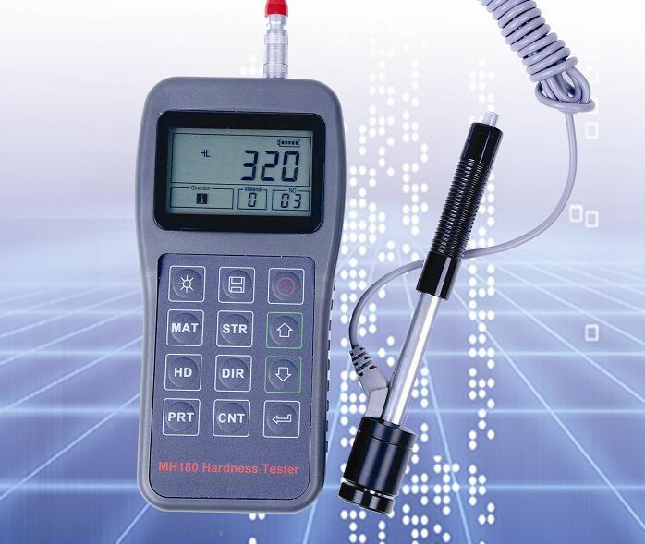

Configuration:
 | No. | Item | Quantity | Remarks
Standard Configuration | 1 | Main unit | 1
Standard Configuration | 2 | D type impact device | 1 | With cable
Standard Configuration | 3 | Standard test block | 1
Standard Configuration | 4 | Cleaning brush (I) | 1
Standard Configuration | 5 | Small support ring | 1
Standard Configuration | 6 | Alkaline battery | 2 | AA size
Standard Configuration | 7 | Manual | 1
Standard Configuration | 8 | Instrument package case | 1
Optional Configuration | 9 | Cleaning brush (II) | 1 | For use with G type impact device
Optional Configuration | 10 | Other type of impact devices and support rings |  | Refer to Table 3 and Table 4 in the appendix.
Optional Configuration | 11 | DataPro software | 1
Optional Configuration | 12 | Communication cable | 1
Optional Configuration | 13 | Micro Printer | 1
Optional Configuration | 14 | Print cable | 1

Technical Specifications:
- Measuring range：
(170-960)HLD,(17-68.5)HRC,(19-651)HB,(80-976)HV,(30-100)HS,(59-85)HRA,(13-100)HRB
- Measuring direction：360°（↓↖↗↘↙→←↑）
- Hardness Scale：HL、HB、HRB、HRC、HRA、HV、HS
- Display：segment LCD
- Data memory：max. 100 groups（relative to impact times 32～1）
- Working voltage：3V（2 AA size alkaline battery）
- Continuous working period：about 100 hours（With backlight off）
- Communication interface：RS232
Main Application
- Die cavity of molds
- Bearings and other parts
- Failure analysis of pressure vessel, steam generator and other equipment
- Heavy work piece
- The installed machinery and permanently assembled parts.
- Testing surface of a small hollow space
- Material identification in the warehouse of metallic materials
- Rapid testing in large range and multi-measuring areas for large-scale work piece

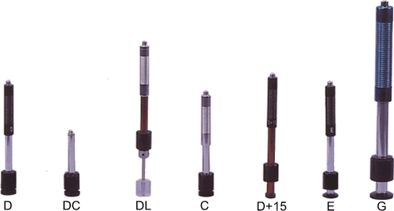
Testing range:

Other type of impact devices
Material | Method | Impact device
Material | Method | D/DC | D+15 | C | G | E | DL
Steel and cast steel | HRC | 20～68.5 | 19.3～67.9 | 20.0～69.5 |  | 22.4～70.7 | 20.6～68.2
Steel and cast steel | HRB | 38.4～99.6 |  |  | 47.7～99.9 |  | 37.0～99.9
Steel and cast steel | HRA | 59.1～85.8 |  |  |  | 61.7～88.0
Steel and cast steel | HB | 127～651 | 80～638 | 80～683 | 90～646 | 83～663 | 81～646
Steel and cast steel | HV | 83～976 | 80～937 | 80～996 |  | 84～1042 | 80～950
Steel and cast steel | HS | 32.2～99.5 | 33.3～99.3 | 31.8～102.1 |  | 35.8～102.6 | 30.6～96.8
Cold work  tool steel | HRC | 20.4～67.1 | 19.8～68.2 | 20.7～68.2 |  | 22.6～70.2
Cold work  tool steel | HV | 80～898 | 80～935 | 100～941 |  | 82～1009
Stainless steel | HRB | 46.5～101.7
Stainless steel | HB | 85～655
Stainless steel | HV | 85～802
Grey cast iron | HRC
Grey cast iron | HB | 93～334 |  |  | 92～326
Grey cast iron | HV
Nodular cast iron | HRC
Nodular cast iron | HB | 131～387 |  |  | 127～364
Nodular cast iron | HV
Cast aluminium alloys | HB | 19～164 |  | 23～210 | 32～168
Cast aluminium alloys | HRB | 23.8～84.6 |  | 22.7～85.0 | 23.8～85.5
BRASS(copper-zinc alloys) | HB | 40～173
BRASS(copper-zinc alloys) | HRB | 13.5～95.3
BRONZE(copper-aluminium/tin alloys) | HB | 60～290
Wrought copper alloys | HB | 45～315
Available type of impact device |  | DC: Test hole or hollow cylindrical | D+15:  Test groove or reentrant surface | C:Test small, light, thin parts and surface of hardened layer | G:  Test large, thick, heavy and rough surface steel | E: Test super high hardness material | DL: Test slender narrow groove or hole

Testing conditions:
Type of impact device | DC(D)/DL | D+15 | C | G | E
Impacting energy  Mass of impact body | 11mJ  5.5g/7.2g | 11mJ  7.8g | 2.7mJ  3.0g | 90mJ  20.0g | 11mJ  5.5g
Test tip hardness:  Dia. Test tip:  Material of test tip: | 1600HV  3mm  Tungsten carbide | 1600HV  3mm  Tungsten carbide | 1600HV  3mm  Tungsten carbide | 1600HV  5mm  Tungsten carbide | 5000HV  3mm  synthetic diamond
Impact device diameter:  Impact device length:  Impact device weight: | 20mm  86(147)/ 75mm 50g | 20mm  162mm  80g | 20mm  141mm  75g | 30mm  254mm  250g | 20mm  155mm  80g
Max. hardness of sample | 940HV | 940HV | 1000HV | 650HB | 1200HV
Mean roughness value of sample surface Ra: | 1.6μm | 1.6μm | 0.4μm | 6.3μm | 1.6μm
Min. weight of sample:  Measure directly  Need support firmly  Need coupling tightly | >5kg  2～5kg  0.05～2kg | >5kg  2～5kg  0.05～2kg | >1.5kg  0.5～1.5kg  0.02～0.5kg | >15kg  5～15kg  0.5～5kg | >5kg  2～5kg  0.05～2kg
Min. thickness of sample Coupling tightly  Min. layer thickness for surface hardening | 5mm  ≥0.8mm | 5mm  ≥0.8mm | 1mm  ≥0.2mm | 10mm  ≥1.2mm | 5mm  ≥0.8mm
Size of tip indentation

Hardness 300HV | Indentation diameter  Depth of indentation | 0.54mm  24μm | 0.54mm  24μm | 0.38mm  12μm | 1.03mm  53μm | 0.54mm  24μm
Hardness 600HV | Indentation diameter  Depth of indentation | 0.54mm  17μm | 0.54mm  17μm | 0.32mm  8μm | 0.90mm  41μm | 0.54mm  17μm
Hardness 800HV | Indentation diameter  Depth of indentation | 0.35mm  10μm | 0.35mm  10μm | 0.35mm  7μm | --  -- | 0.35mm  10μm

Support rings for Shaped Materials:

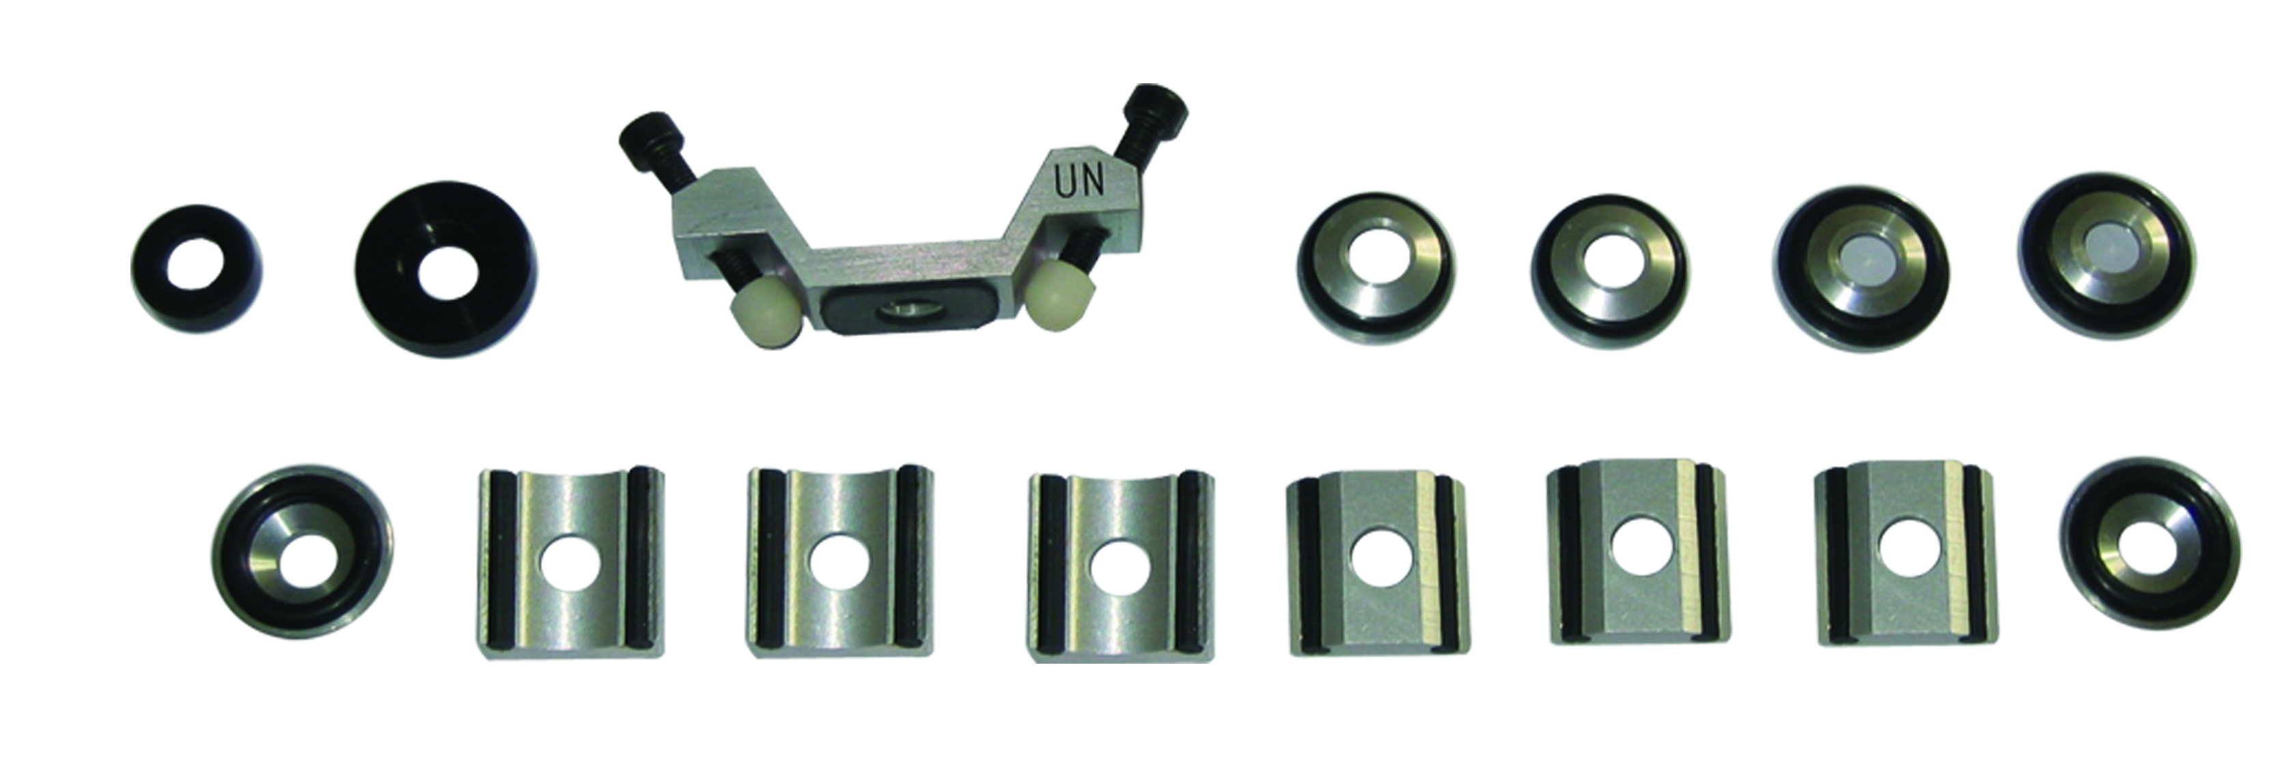

Other type of support rings

No. | Type | Sketch of non-conventional  Supporting ring | Remarks
1 | Z10-15 | 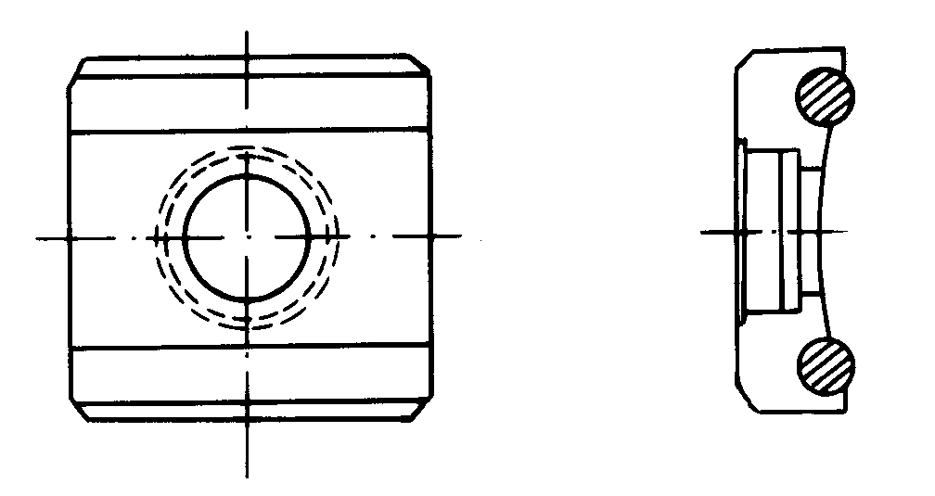 | For testing cylindrical outside surface  R10～R15
2 | Z14.5-30 |  | For testing cylindrical outside surface R14.5～R30
3 | Z25-50 |  | For testing cylindrical outside surface  R25～R50
4 | HZ11-13 | 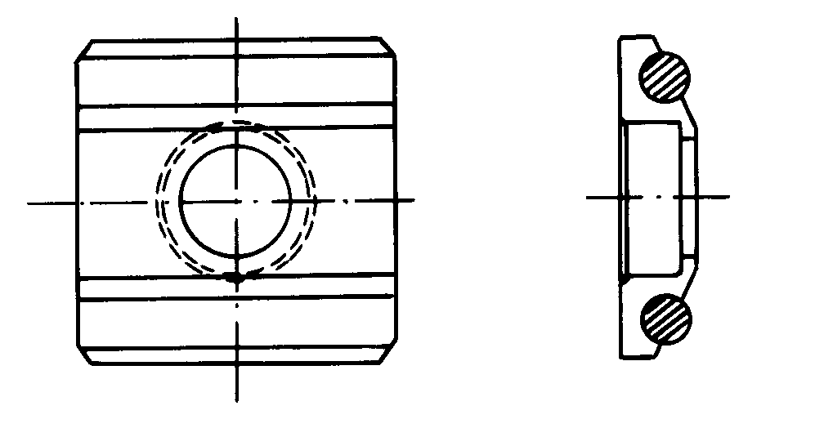 | For testing cylindrical inside surface  R11～R13
5 | HZ12.5-17 |  | For testing cylindrical inside surface  R12.5～R17
6 | HZ16.5-30 |  | For testing cylindrical inside surface  R16.5～R30
7 | K10-15 | 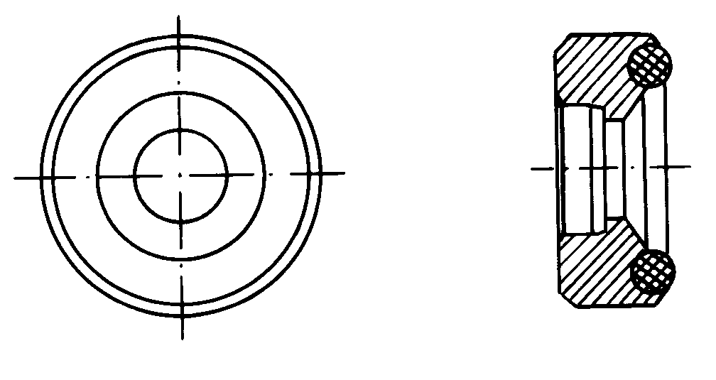 | For testing spherical outside surface  SR10～SR15
8 | K14.5-30 |  | For testing spherical outside surface SR14.5～SR30
9 | HK11-13 | 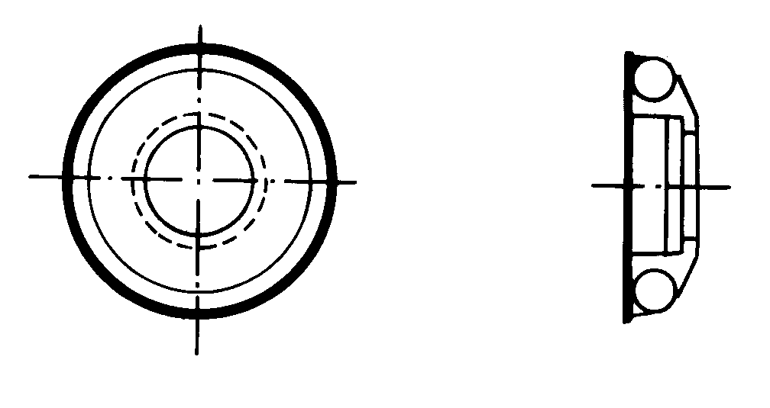 | For testing spherical inside surface  SR11～SR13
10 | HK12.5-17 |  | For testing spherical inside surface  SR12.5～SR17
11 | HK16.5-30 |  | For testing spherical inside surface  SR16.5～SR30
12 | UN | 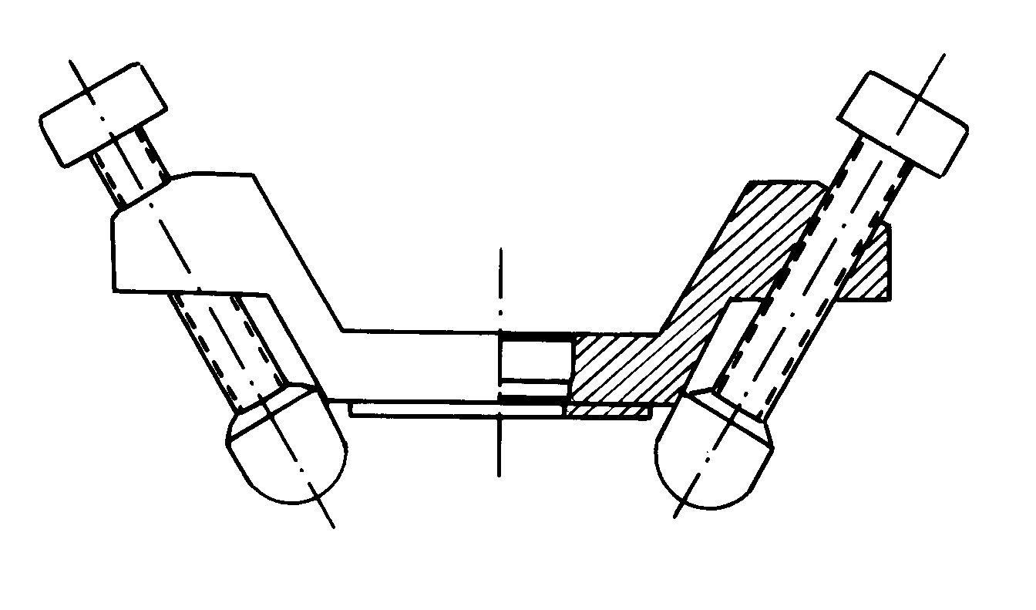 | For testing cylindrical outside surface, radius adjustable R10～∞

www.cnrinch.com cnrinch@yahoo.com.cn

